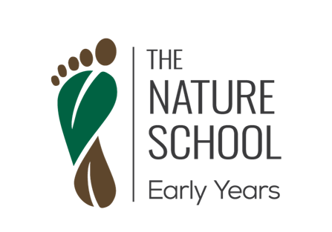

The Nature School Early Years

Roles and Responsibilities: Educator

Your responsibilities may include but are not limited to the following:
● Assist in the delivery of a completely outdoor preschool program, as part of a team of 2-3 educators. The program will run for either 3 or 6 hours.
● High level supervision of children in high-risk situations such as play by bodies of water, tree climbing, lighting fires and exploration of wild bushland. Maintain professional and industry standards while keeping the magic of learning alive.
● Provide developmentally appropriate care and education for children aged 3-5 years old in a natural, outdoor environment.
● Decision making and risk management in the outdoor environment/bushland, including but not limited to the monitoring and management of risk posed by wildlife, weather, fire, intruders and children’s health issues.
● Possess a responsible, punctual and ethical way of working.
● Adaptable and appropriate communication with children, parents and staff.
● Prioritise genuine engagement with families, parents and carers.
● Assistance in setup, organisation and pack up of program equipment.
● Ability to work collaboratively and effectively in a small team.
● Ensure that children are safe and adequately supervised at all times
● Follow all guidelines of employment as per staff employment agreement and associated TNS Inc. organisational and ELP policies, procedures and Code of Conduct.
● Respond positively and consistently to children’s additional needs/requirements – diet/allergies, developmental etc.
● Be able for physical activity including but not limited walking, running, climbing etc.
● Be proactive in own professional learning and development.
● Be comfortable with children taking safe risks in a nature setting.
● Be comfortable working outdoors in any weather situation, including rain.

Desirable Qualifications:
Diploma or Certificate III Early Childhood Education and Care

